Community Service

“Everybody can be great because everybody can serve.” Martin Luther King Jr.

Benefits

Helps Others

Spreads Joy

Provides Self-Fulfillment

Provides Self-Accomplishment

Improves your Resume

Improves your Community

Improves your Mood & Self-Esteem

Teaches you new Job Skills

Allows you to Meet New People

Can Improve Academic Performance

Local Volunteer Opportunities

Nursing Home

Hospital

Adopt-A-Highway

Animal Shelter

Food Bank

4-H Club

Service Clubs (Rotary, Woman’s, Garden, etc)

Library

Energy Express

Arts Alliance

Historical Society

Giles County Clean Up Day



Mavericks Volunteer.

Be a Maverick!

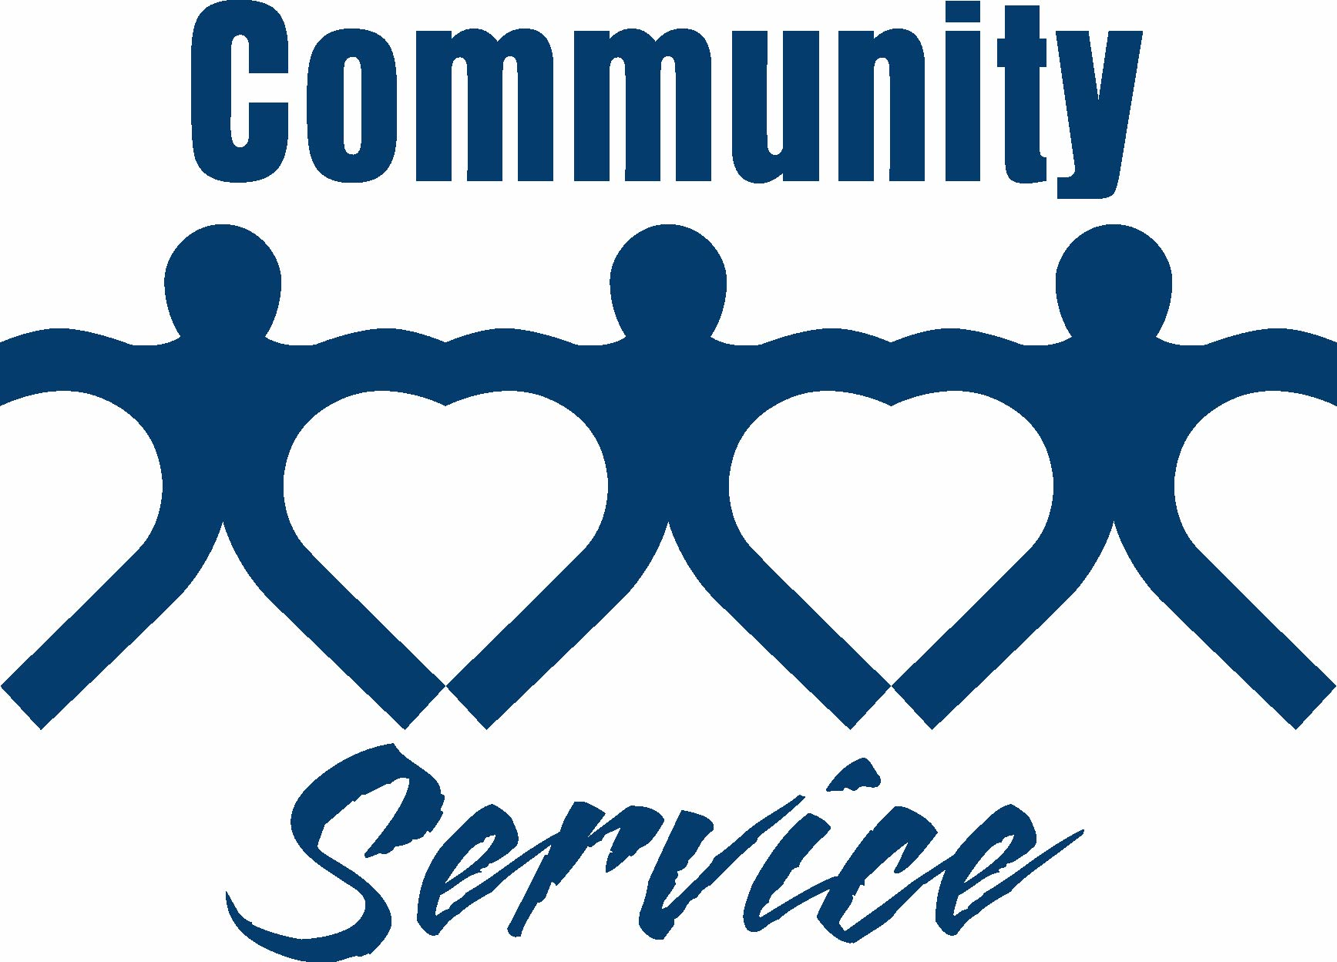

Pay It Forward

Together we can change the world one good deed at a time!

The Pay It Forward idea creates a ripple effect of good deeds. Someone does something nice for you, and in turn you do something nice for another person.

Good deeds you can do…

Open the door for someone

Compliment someone

Buy a drink/snack for a stranger

Help a classmate with homework

Do a chore at home

Carry an elder’s groceries

Start the ripple at JMHS! Do a good deed today!

“A life lived for others, is the only life worth living.” Albert Einstein

“If you can’t feed a hundred people, then just feed one.”

Mother Teresa

“Pay it forward with free compliments. They are returned in due time.” David Chiles

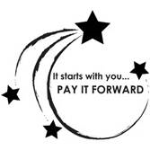

Mavericks Pay It Forward.

Be a Maverick!