Be Thankful
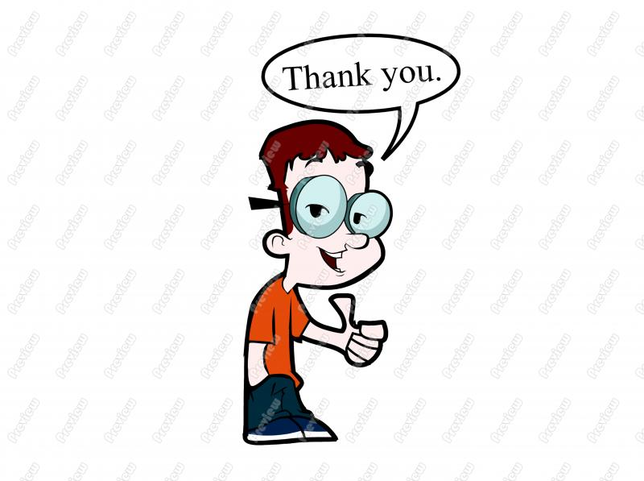
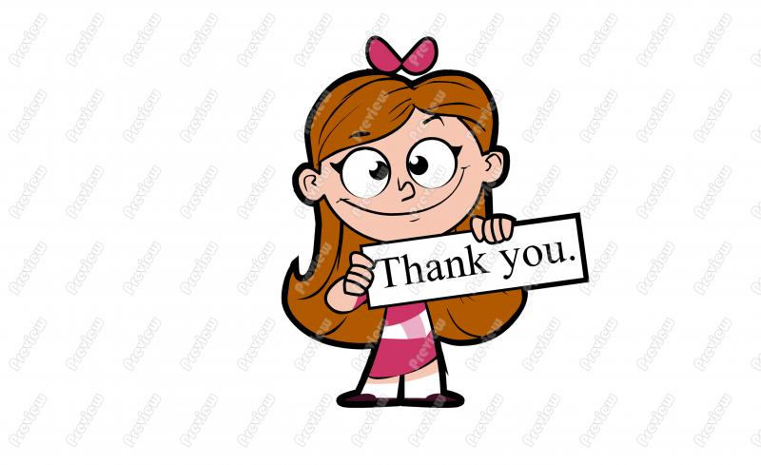

Consider these thoughts…

“No duty is more urgent than that of returning thanks.”
-James Allen

“Give thanks for a little and you will find a lot.”
-Hansa Proverb

“We often take for granted the very things that most deserve our gratitude.”
-Cynthia Ozick

Thank someone today!

Mavericks give thanks.
Be a Maverick!
ATTENTION:
Take a moment and think of three things you are thankful for today.

…

Need some guidance? Finish these sentences.

- I am thankful for ________ because ______________.
(person)

- I am thankful for ________ because ______________.
(event)

- I am thankful for ________ because _______________.
(thing)

Thank someone today!

Mavericks give thanks.
Be a Maverick!

