This year, and every year, remember to…

BE RESPECTFUL.

BE RESPONSIBLE.

BE SAFE.

BE A MAVERICK!

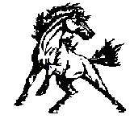
What will you learn this year…

Shakespeare?
Civil War facts?
The Quadratic formula?
Parts of a cell?

Whatever you learn, know this:

“Education is the most powerful weapon which you can use to change the world.”
Nelson Mandela

Let’s have a great year!

Be Respectful.
Be Responsible.
Be Safe.
Be a Maverick!

