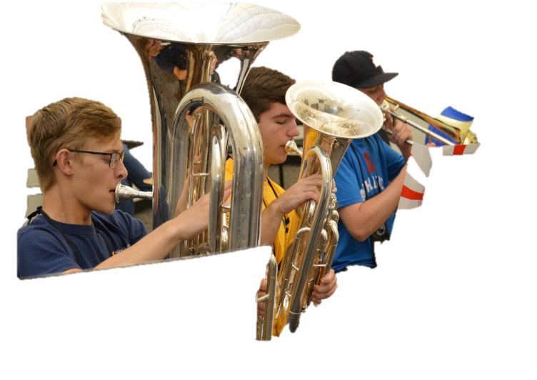
Dear Sophomore,
I am writing to tell you about the chance of a lifetime, and I hope you are willing to take that chance. In summer 2020, approximately 118 students your age will spend three weeks on the campus of Marshall University, living in a community of artists. The Governor’s School for the Arts (GSA) is financed by the legislature and managed by the West Virginia Department of Education, so it is FREE.
If you have a talent in writing, dancing, singing, acting, digital media art, painting or drawing, or in playing an instrument, and you would like to spend three weeks on a college campus at no cost, consider the Governor’s School for the Arts. It might be just where you want to spend an unforgettable summer! Take five minutes to view the video about GSA: https://www.facebook.com/wvgsa2019/videos/1280732465415604/and you will definitely be interested.
Imagine that you are a painter and that each morning for three weeks you will be going to the studio to work with 13 or 14 other students under the direction of an accomplished artist. Imagine that the class is going to last for three hours, giving you time to throw yourself into your creation. If you are a dancer, consider the opportunity you'll have to stretch and grow in both classical ballet and modern dance. The classes are small, the passion is intense, and the growth is simply phenomenal.

The same growth opportunities exist for students in the other arts disciplines at GSA, a three-week residential program providing individual and in-depth group instruction in the arts for current high school sophomores living in and attending school in West Virginia.
Upon arrival last year, one student told her mother, “These are my people; this is where I belong.” Another said, near the end of the GSA, “Words don’t express how grateful I am for this experience. It is something that will follow me beyond here….It will follow us all from here.”
All you have to do to find out more about how to apply for GSA is go to http://govschools.wv.gov/gsa. From there you can follow the links to the applications as well as information about how to plan for your audition.
If you have questions, feel free to contact me at Cheryl.keffer@k12.wv.us or by phone at 304-640-0988.
Sherry Keffer, Coordinator of Governor’s Schools
West Virginia Department of Education
Building 6, Room 221
1900 Kanawha Boulevard, East
Charleston, WV 25305

The deadline for applying is December 16. Get busy!

