JMHS Cadets at the House of Delegates
Cadet Major Nathan Wilson

The James Monroe High School (JMHS)/ Monroe County Technical Center (MCTC) Army Junior Reserve Officers’ Training Corps (JROTC) program has made a name for itself in the local community over the last four years by participating in local community events such as dinners for the seniors and children of Monroe County, giving presentations to the young students of Peterstown Elementary and Mountain View Elementary and Middle School during their “Red Ribbon Week” campaigns, and participating in local parades in Lindside, Peterstown, and Union. On February 4th, the Maverick Battalion took one more step in getting its name known to the community.
On this, the first Wednesday of the month of February, cadets from JMHS/MCTC JROTC journeyed to the state capital in Charleston to present our great nation’s colors to West Virginia House of Delegates. This was an opportunity for the Maverick Battalion to become known not only in the local community, but state wide. The color guard consisted of four experienced cadets, Cadet Staff Sergeant Josiah Womack, Cadet Command Sergeant Major Levi Waldron, Cadet Captain Julia Persinger, and Cadet Major Nathan Wilson.
The four cadets, along with the rest of the unit, wowed the Delegates and later received a standing ovation when being introduced and welcomed by Delegate Roy G. Cooper of the 28th district. Delegate Cooper, a retired member of the United States Navy, helped make this trip possible for the Maverick Battalion by working with instructors Scott Womack and Michael Wiley for weeks prior to the meeting.
After the visit to the Capitol the Maverick Battalion traveled to the West Virginia Air National Guard base in Charleston and had the opportunity to see a C-130 Hercules aircraft and speak with two crewmembers about its capabilities. The cadets learned about the various configurations of the aircraft, which is capable of carrying and air dropping both cargo and personnel, and were able to sit in the cockpit and learn about the duties performed by the air crew.
The cadets highly appreciated the opportunity to visit the capital and meeting representatives of the House including Mr. Cooper and many others. The trip marks as a stepping stone to what the Battalion can achieve, not only in the community or even the state, possibly even bigger.
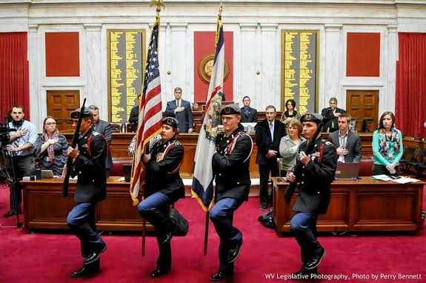
Cadets (L:R) C/CSM Levi Waldron, C/CPT Julia Persinger, C/MAJ Nathan Wilson, C/SSG Joe Womack presenting the colors

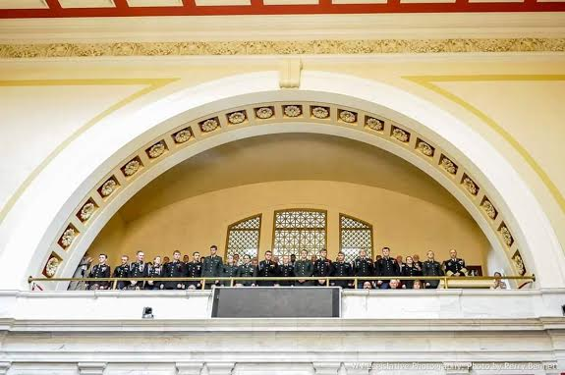
Maverick Battalion Cadets being recognized by Delegate Cooper at the House Session

